Comms Software General Description:

Created by: Millpreet Kamboj

Edited by: Nick Mitchell and Alexis Pascual

Last Time Edited: 2021-03-31

# Data Transfer Modes Designed:

1. Downlink Telemetry and Housekeeping data
   1. Instantaneous Housekeeping data
   2. List files on Cubesat
   3. Downlink telemetry and housekeeping data from x time.
2. Downlink Images
   1. Send image thumbnails
   2. send specific image
3. Schedule Image Capture
   1. Capture image(s) with at x time.
4. Onboard Computing Update Command
   1. Can include system image or select files on Cubesat.
5. Stop all communications (IARU requirement as well)
6. Uplink Telecommands
   1. Reformat SD card
   2. Update TLE values
   3. Delete file(s)
   4. Reboot system
   5. Schedule rotation of Cubesat for power generation purposes.

# Frame Description:

## Start I-Frame:

* Ground station transmits to satellite to Start Information Sending Frame that sets up parameters such as:
  + Command for current transmission
  + Maximum end transmission time
  + Next time to transmit

## TT&C I-Frame:

* Frame transmitted by satellite containing Telemetry, Tracking, and Command data

Contains the following sensor information:

* OBC time
* Battery voltages and currents
* Temperature Sensors
* Solar Panel voltages + currents
* Magnetorquer current/volt
* Magnetic compass sensor
* Gyroscope data
* Uptime between last update to the epoch
* Antenna deployment currents
* Payload health information (tbd)
* Etc…

## Acknowledge S-Frame (ARQ)

* Supervisory frame used to transmit from the ground station to the satellite to acknowledge frames received and to request next action to be conducted

4 possible actions:

* Acknowledge send next frame
* Acknowledge do not send next frame
* Selective Reject a frame for retransmission
* Reject all frames, retransmit all

## VR camera I-Frame

* Information frame transmitting images from the satellite

2 modes to send images in varying qualities:

* Primary mode to send back 12-bit JPEG images at 3000x3000 pixels per image at 13.5MB
* Secondary mode sends back images with up to 15x compression <1MB per image using lower bit depth

## OBC (Onboard Computing) Update I-Frame

* Information frame transmitting from ground station up to satellite to update or patch onboard computer flight software

## End Transmission S-Frame:

There will be 2 types of end transmission S-Frames:

1. Supervisory frame used to transmit to the Satellite to end transmission at the end of the current command.
2. Supervisory frame used to transmit to the Satellite to end transmission at the end of a transmission period. This happens when the satellite is no longer in communication range of the groundstation.

# Downlink Image Command:

## Diagram:

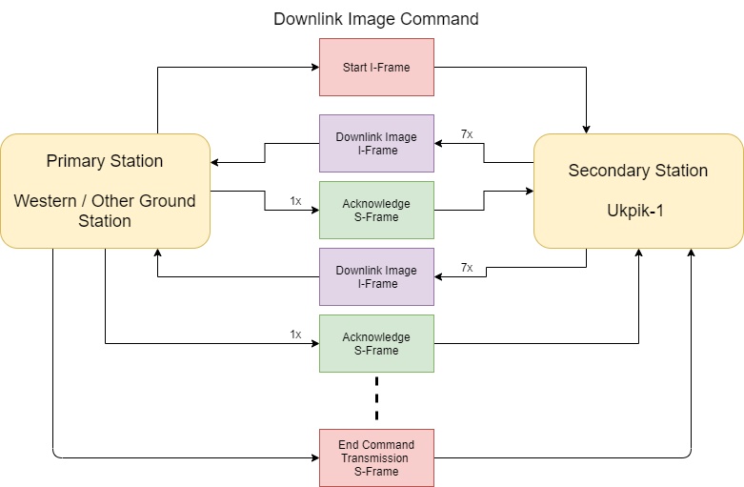

## Description:

1. 1x Start I-Frame transmitted from ground station to begin a communication sequence with an image transmission command (other functionalities work in similar manor)
2. 7x Camera downlink image I-Frames w from satellite to collect payload camera data.
3. 1x acknowledge S-Frame transmitted from ground station to acknowledge received info and decide what next action is based on the 4 possible actions provided in [HERE](#_Acknowledge_S-Frame_(ARQ))
4. Continue with steps 2 and 3 until done with command or time to transmit runs out.
5. 1x End Command Transmission S-Frame that will end the current command sequence.

# OBC Update Command:

## Diagram:

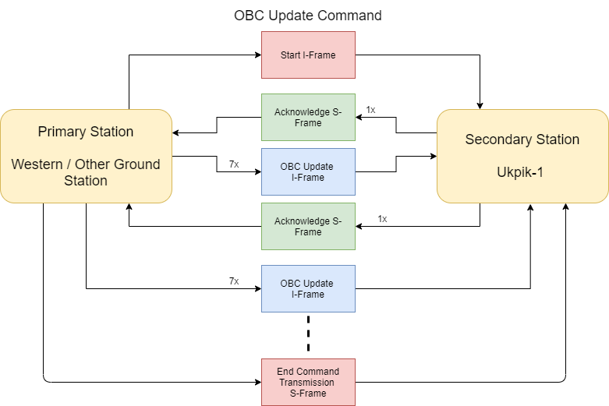

## Description:

1. 1x Start I-Frame transmitted from ground station to begin a communication sequence with OBC patch command
2. 1x acknowledge S-Frame transmitted from satellite to acknowledge received info and decide what next action is based on the 4 possible actions provided in [HERE](#_Acknowledge_S-Frame_(ARQ))
3. 7x OBC Update I-Frames transmitted by ground station to the satellite to provide data for OBC Patch
4. Continue with steps 2 and 3 until done with command or time to transmit runs out.
5. 1x End Command Transmission S-Frame that will end the current command sequence.

# Image Acquisition Command:

## Diagram:

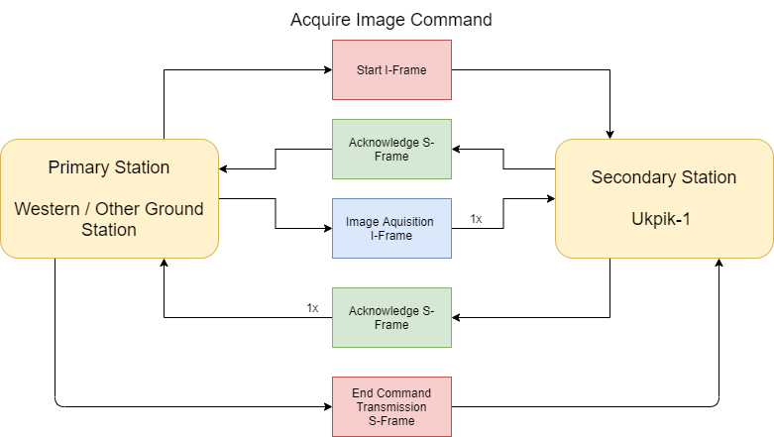

## Description:

1. 1x Start I-Frame transmitted from ground station to begin a communication sequence with Acquire Image command
2. 1x acknowledge S-Frame transmitted from satellite to acknowledge received info and decide what next action is based on the 4 possible actions provided in [HERE](#_Acknowledge_S-Frame_(ARQ))
3. 1x Image acquisition frame which will detail the next time to image.
4. 1x acknowledge S-Frame transmitted from satellite to acknowledge received info and decide what next action is based on the 4 possible actions provided in [HERE](#_Acknowledge_S-Frame_(ARQ))
5. 1x End Command Transmission S-Frame that will end the current command sequence.

# Telemetry and Housekeeping Data Command:

## Diagram:

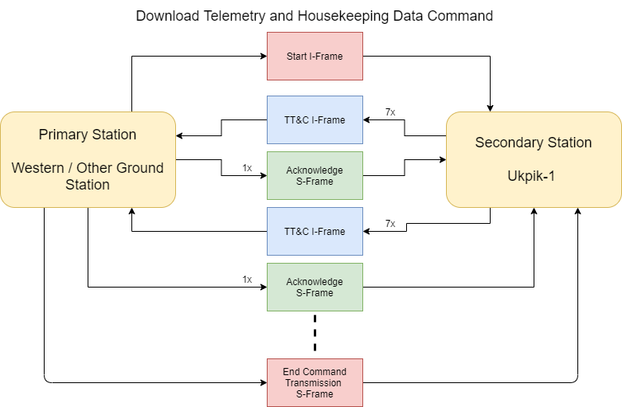

## Description:

1. 1x Start I-Frame transmitted from ground station to begin a communication sequence with a telemetry and tracking transmission command (other functionalities work in similar manor)
2. 7x TT&C I-Frames transmitted from satellite to collect housekeeping data.
3. 1x acknowledge S-Frame transmitted from ground station to acknowledge received info and decide what next action is based on the 4 possible actions provided in [HERE](#_Acknowledge_S-Frame_(ARQ))
4. Continue with steps 2 and 3 until done with command or time to transmit runs out.
5. 1x End Command Transmission S-Frame that will end the current command sequence.

# Stop Communication Command:

## Diagram:

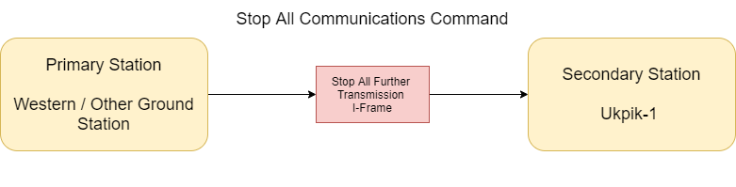

## Description:

1. 1x Start I-Frame transmitted from ground station to send Stop Communication command**.**

This will prevent the transmission of any RF signals from the Ukpik-1 satellite until a restart command is received. The satellite will still be able to listen to signals via the receiver.

# Restart Transmission Command:

Diagram:

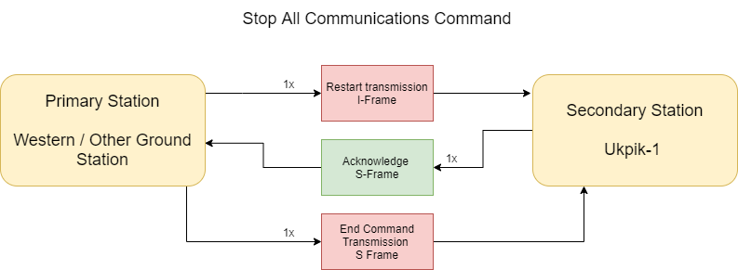

## Description:

1. 1x start I-Frame transmitted from ground station to send the restart transmission communication command.
2. 1x acknowledge frame from the Ukpik-1 satellite (since it is now able to transmit again).
3. 1x end command I frame to terminate this command sequence.